GROWTH OPTIMIZATION BLUEPRINT

An AI-Driven Marketing & Retention Framework Built on Customer Segmentation, Churn Prediction and Sales Forecasting

ZENKART



Case Objective & Business Motivation
Zenkart has grown rapidly in the Indian D2C tech accessory space, but recent instability in metrics indicates a potential slowdown. The company sees:
Observed Problem | Business Risk
Sales fluctuate heavily | Unpredictable cashflow
Repeat buyers decreasing | Declining customer lifetime value
Uneven SKU performance | Inefficient product inventory
High delivery time variance | Poor service reputation
Demand differs across cities | Difficulty scaling
Churn increasing | Rising acquisition cost

Goal of this Study
To utilize Zenkart’s transactional, customer and product data to:
- Clean and preprocess data with intelligent imputations
- Perform Customer Segmentation with Clustering
- Predict Churn probability & identify churn-drivers
- Forecast future sales for planning & inventory decisions
The final deliverable is not only model output, but business-transforming insights.

Data Processing Pipeline

Dataset Overview
Rows | Columns | Data Type
951 transactions | 25 features | Mixed (categorical + numeric + temporal)
Column groups:
- Customer Demographics → Age, CityTier, Income
- Purchase Behaviour → Quantity, TotalOrders, NetSales
- Product Attributes → Category, MRP, Cost
- Service Quality → DeliveryTime, Returned, Rating
- Time Variables → Year, Month, Week, Day

Date-Time Feature Engineering
OrderDate was converted into 7 discrete components:
Date | Year | Month | Week | Day | DayOfWeek | Time
Why?
This allows seasonality understanding, week-over-week trend analysis, sales cycle behaviour, and long-term forecasting.
After decomposition, OrderDate was removed to avoid redundancy.

Missing Values - Detection
Column | Missing Count | Percent
DeliveryTime | 38 | 3.99%
Age | 43 | 4.52%
Income | 48 | 5.05%
Rating | 210 | 22.08% (largest gap)

Missing Values - Treatment + Justification
Feature | Imputation Method | Reasoning
DeliveryTime | Median per Category × CityTier | Delivery varies by product + location → Avoids unrealistic filling
Age | Median per CityTier | Cities have different lifestyle demographics
Income | Median per CityTier | Income strongly linked to geography
Rating | Mode per Category | Rating is categorical + depends on product experience
Used conditional imputation instead of global mean to avoid artificial smoothing
Ensures repaired values reflect real market behaviour

Outlier Detection & Treatment
Performed IQR-based outlier detection:
Feature | Outliers Found | Lower–Upper Limit
Price | 3 | -2180 → 7421
CLV | 3 | -1961 → 24740
DeliveryTime | 3 | -1.2 → 9.2 days
Replaced using Winsorization (clip).
Why not delete outliers?
- Outliers represent extreme but real customers
- Deleting = information loss
- Clipping = stabilizes variance while retaining records
After treatment → Outliers remaining = 0
Dataset is model-ready.

Data Type Validation
All numeric fields were verified as numeric and categorical fields were converted to string.
Result | Status
Numeric integrity | No invalid values
Categorical integrity | Clean & consistent

Feature Creation – NetSales
NetSales = Price × Quantity × (1 – Discount%)
More reliable than using price alone → incorporates discounting effect.
Used throughout segmentation, modelling and forecasting.

Customer Segmentation (K-Means Clustering)

Features Used:
Age, Income, TotalOrders, CLV, TotalRevenue, TotalQuantity, AvgDeliveryTime, Rating
After Scaling:
Model Selection Method | Result
Silhouette Method | Best = K=2
Elbow Method | Best = K=3 → chosen
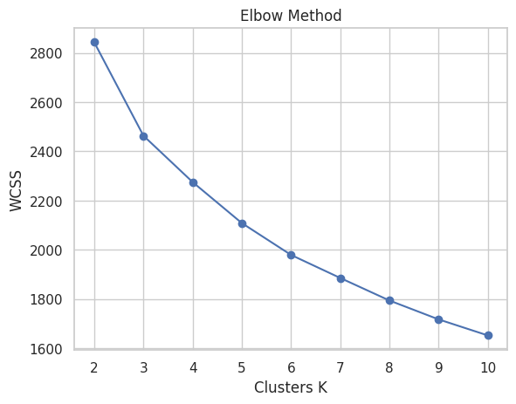
Why choose 3 instead of mathematically optimal 2?
3 clusters allow actionable segmentation
2 clusters are too broad for business strategy
goal = interpretability > pure statistic score

Final Clusters (Averages)
Cluster | Profile Summary | Behaviour | Action Plan
0 | Age 44, High CLV | Mature, long-term high loyalty | Convert into Membership+VIP
1 | Highest revenue + quantity | Bulk buyers with mid-income | Push cross-sell bundles
2 | Youngest, Low CLV | Price-sensitive, likely churn | Improve delivery, loyalty cashbacks
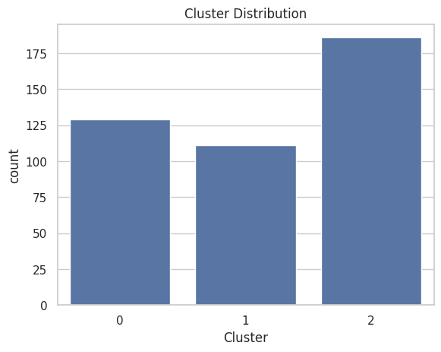
PCA confirms clear separability → segmentation reliable
Revenue strategy optimized per segment
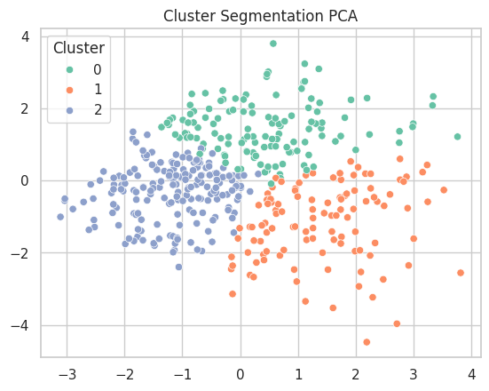

Churn Prediction – Machine Learning

Model Inputs:
- Customer Value → CLV, NetSales
- Behaviour → TotalOrders, Returned
- Service → DeliveryTime, Rating
- Demographic → Age, Income, CityTier

Model | Accuracy | AUC | Final Use
Logistic Regression | 0.85 | 0.90 | Baseline model
Random Forest | 0.97 | 0.986 | Selected Model
XGBoost | 0.97 | 0.982 | Validated performance stability
XGB + RF both strong → RF selected for interpretability + stability

Churn Driver Ranking (Feature Importance)
TotalOrders > Income > CityTier > CLV > DeliveryTime > NetSales > Rating > Age > Returned
Biggest churn signal = Low order frequency
Interpretation:
Customers leave because they never build purchasing habit → nurture early repeat!
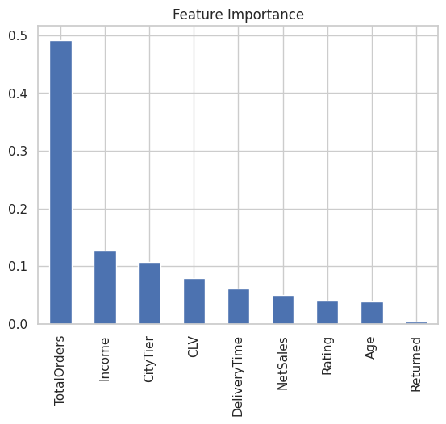

Profitability Analysis (Strategic Insight)
Category | NetSales | Profit | Margin%
Smartwatch | 4724.7 | 4139.7 | 63.98% (Highest)
Cable | 4691.3 | 3472.9 | 49.00%
LaptopAccessory | 4942.2 | 3403.6 | 36.50%
Earphones | 4759.5 | 3073.8 | 26.55% (Lowest)

Business Interpretation
Product | Should We Push It? | Why
Smartwatch | YES – aggressively | Very high margins → huge profit capture
Earphones | Reevaluate strategy | High volume but weak profitability
Laptop Accessory | Moderate push | Good revenue, acceptable margin
Cable | Foundation product | Reliable stable revenue driver
Opportunity:
Bundle Earphones + Smartwatch = Fix margin + volume imbalance

Customer Lifetime & Retention Flow

Repeat Customer Rate: 81.49%
High retention → strong loyalty base.
CityTier | Repeat %
Tier-2 | 83.28% (best)
Tier-1 | 80.83%
Tier-3 | 80.16%
Finding → Tier-2 buyers are most loyal
Growth can scale faster beyond metro markets.

Cohort Retention Behaviour (first 5 months)
Month After First Purchase | Retention %
Month-1 | 23.8%
Month-2 | 17.8%
Month-3 | 16.6%
Customers churn within first 90 days if not nurtured.
Solution:
3-Month Nudge Strategy
1st week → discount on 2nd purchase
30 days → recommendation mail
90 days → win-back coupon
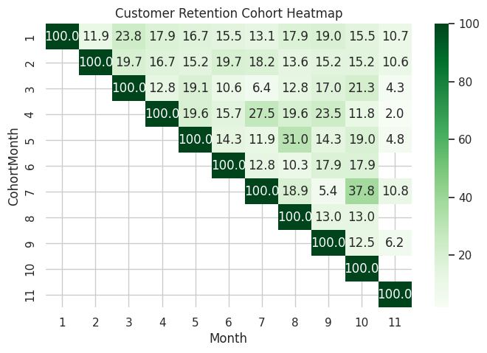

Marketing Execution Roadmap (Quarter-wise Plan)
Quarter | Focus | Action
Q1 | Fix churn | Early-repeat coupons, delivery improvement, feedback capture
Q2 | Boost revenue | Smartwatch push, bundles, influencer tie-ups, Tier-2 ads
Q3 | Expand | Offline pop-up stalls, tech-fest sponsorships
Q4 | Optimize | Recommendations engine A/B test, CLV-based pricing

Time Series Forecast – ARIMA + Confidence Bands
Weekly aggregated forecast (12 weeks ahead):
60833 → 94002 increasing trend
Total future revenue estimate ≈ 1.06 Crore
Confidence interval forecast provides best-case/worst-case scenarios → useful for inventory and procurement planning.
Inventory & marketing reinforcement recommended.
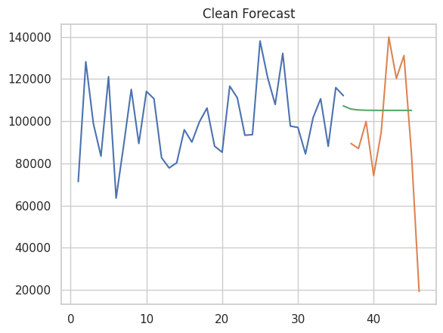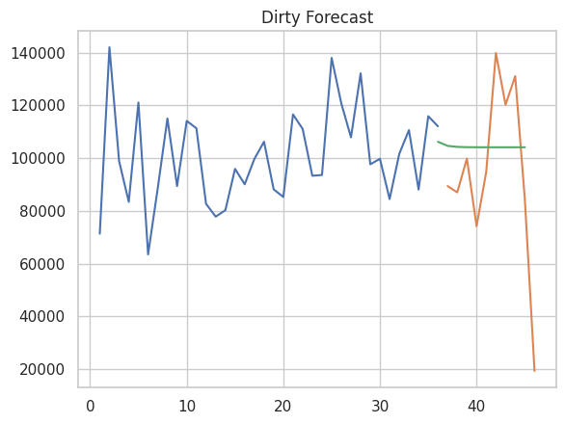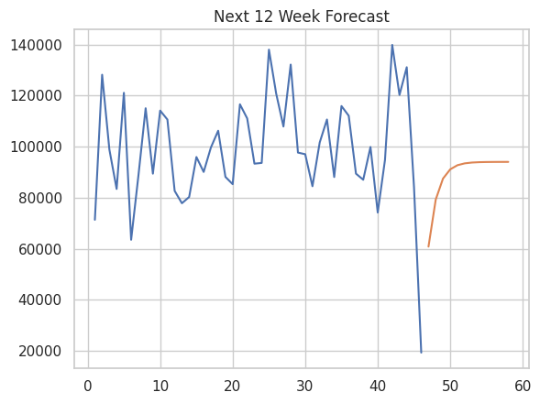

Auto-Generated Intelligence Summary
Top Revenue Category: Cable
Highest Profit SKU: Smartwatch
City With Strongest Demand: Tier 1
Top Retention Zone: Tier 2
Primary Churn Factor: Total Orders
Repeat Purchase Rate: 81.49%
Predicted Revenue (12 weeks): ₹10.68 Lakhs / ~1.06 Cr

Final Key Recommendations

Revenue Growth
Promote Smartwatches → highest margin
Create Accessory Bundles → Cable + Earphones + Laptop Add-on
Invest more into Tier 2 Customer Acquisition

Retention / Churn Reduction
Target low order users → 1-Click reorder offers
Shorten average delivery time for Cluster-2
Incentivise 2nd and 3rd purchase within 90 days

Forecast & Inventory
Stock more high-margin SKUs in next quarter
Build campaign calendar aligned to weekly forecast peaks

Long-term Data Strategy
Introduce RFM scoring
Customer-wise lifecycle journey automation
Deploy recommendation engine for upsell

